**Team Information**

Supervisor: Mohammed Ali

Group: 5.WED-1430-4

|  |  |
| --- | --- |
| **Student ID** | **Name** |
| Brenton Manks | s3078901 |
| Si Long Leong | s3785099 |
| John Lam | s3681915 |
| Mohammed Abdullah H Almahdawi | s3761295 |
| Jonathan Vernik | s3786227 |

**VISION:**

When approached by the client, we were expected to develop a full stack web application using appropriate technologies, process and tools. The program is implemented in java for the back-end using the SpringBoot framework and javascript for front-end using react. We were also requested to deploy our project onto the cloud computing platform “AWS“.

Over the 12 week long duration of the project, the web based application was successfully deployed on AWS. Various technologies such intelliJ, POSTGRES, POSTMAN, Docker, Kubernetes and microsoft studio visual code were used for each section of the project. By using multiple technologies it allowed for us to specifically approach the project with different strengths of each application. This resulted in a smooth transition to deployment.

What makes this product valuable is that it is not only built within the specified time from, but deployed online with version control, thoroughly documented and as well as easily upgradable. The purpose of this project was to deploy a shippable functional version of the product that can be upgraded whilst being actively used. Every upgrade to the system did not affect the active running version.

**System Architecture / Design**

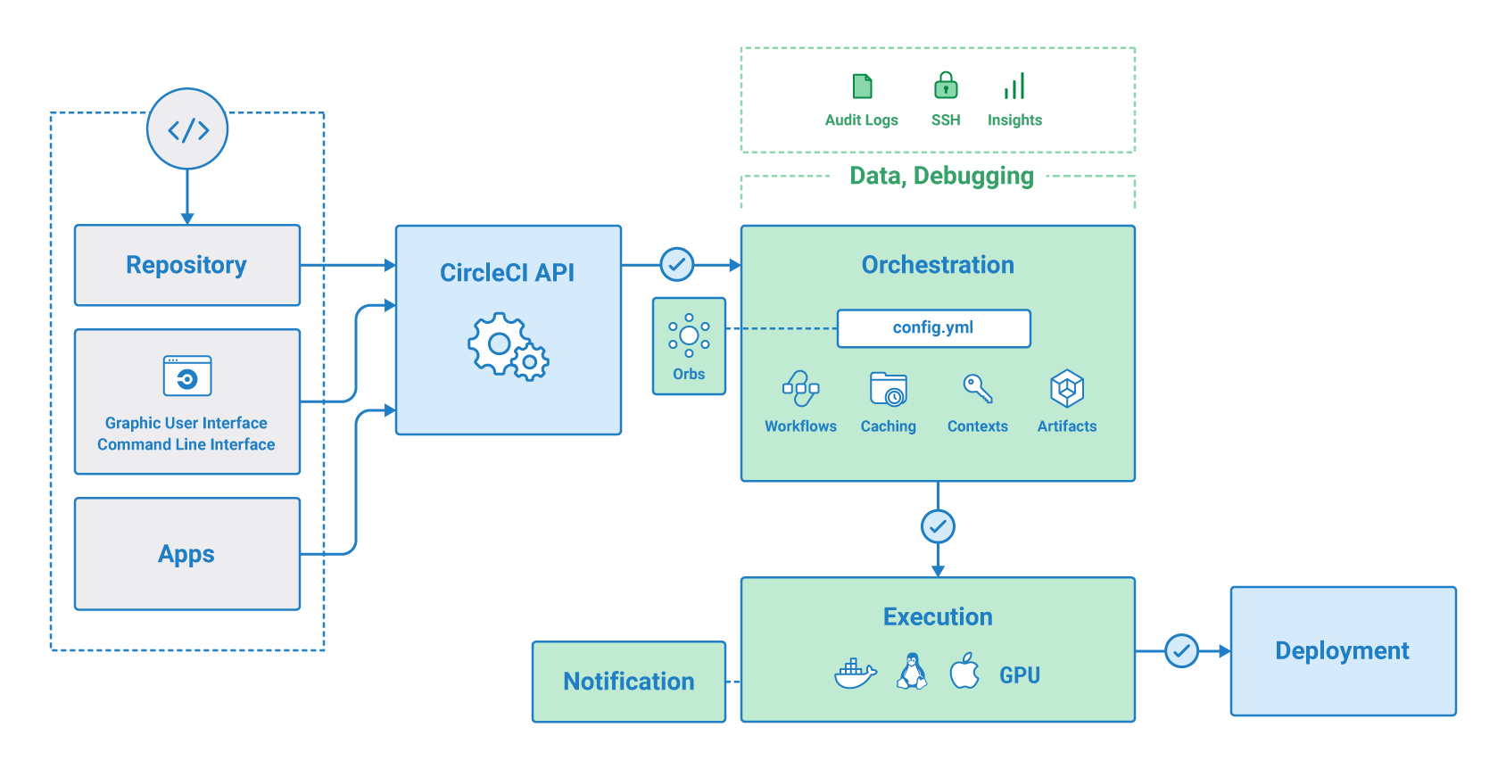

circleci.com. (n.d.). *Overview - CircleCI*. [online] Available at: https://circleci.com/docs/2.0/about-circleci/ [Accessed 18 Oct. 2020].

**Refactoring:**

We did not Refactor any lines of code during this project. We communicated and investigated each feature before we began coding. This ensured that everyone had a standard and a basic level of understanding of each feature even though we were not assigned to the user story.

**GitFlow organisation:**

Throughout the project the git commits varied depending what other assessments from other subjects are present. As people were working on their sections of code, people would push or pull as requested. Once we familiarized ourselves with how to branch sections of code, we became more organised.

We often pushed our branches towards the end of each sprint or if we did informal code inspections. At the end of each milestone we merged all the branches into the master branch.

**Scrum Process:**  
We had one Planning meeting at the start of every sprint, we had stand ups every monday, wednesday and friday, a retrospective on the last day of the sprint and a sprint review at the end of every sprint with the product owner.

When communicating with the team, we also started conversations through ms teams depending on the topics. We assigned our tasks using Trello boards and submitted all our documents to a shared Google drive.

To ensure a positive learning experience, Si Long Leong was assigned Scrum master but every meeting someone would take over as a temporary scrum master. We each had our own fields of expertise and assigned roles within the team.

**Deployment pipeline set up:**

Kubernetes using minikub:

